2000_PTR Enrollment initiated by CE - New Move in
Combo
1.Contract No. 4009690592
Material No. 88000105
Serial No. 29101113
Equipment No. 100005155098
Contract Account. 100023406018
Functional Location. 6002276745
2.Contract No. 4009690559
Material No. 80010079
Serial No. 25169178
Equipment No. 100002881783
Contract Account. 100023406018
Functional Location. 6002276760

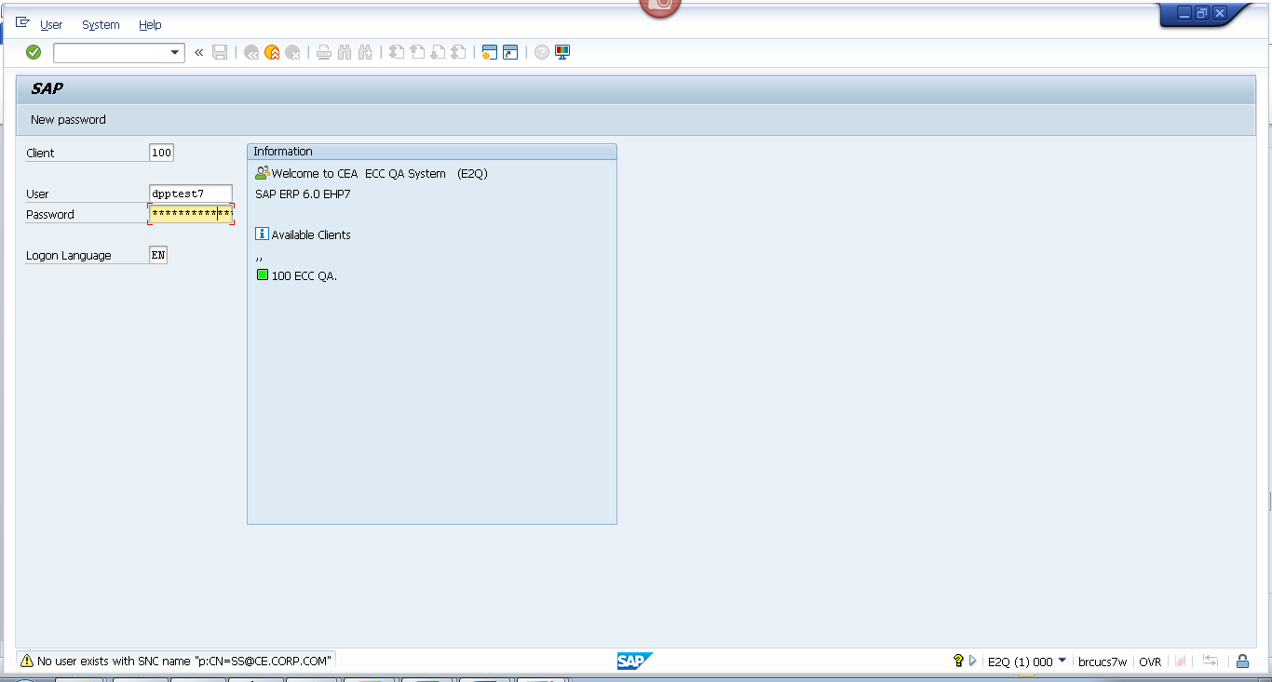
Contract 1
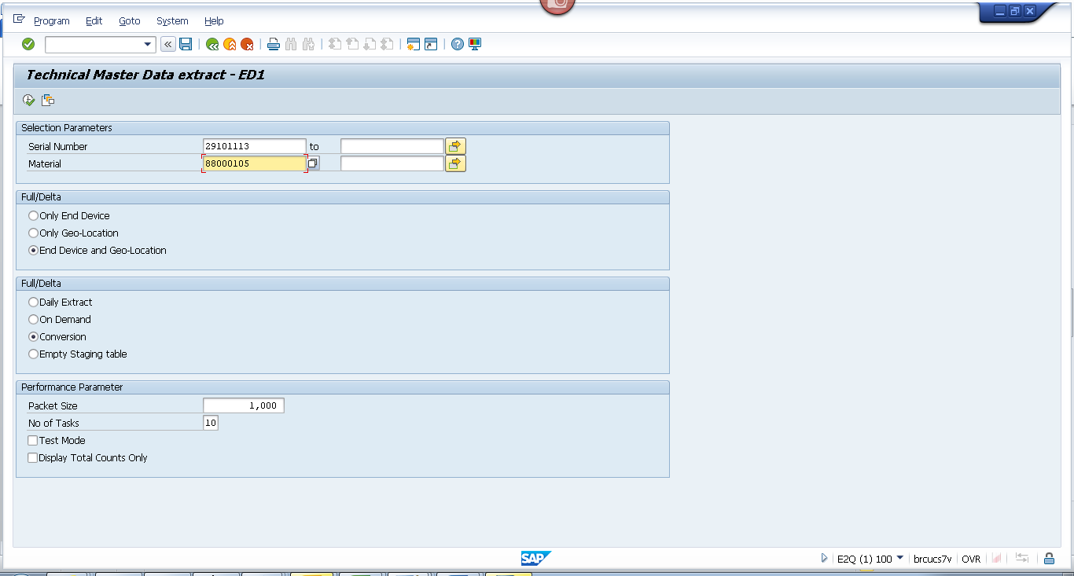
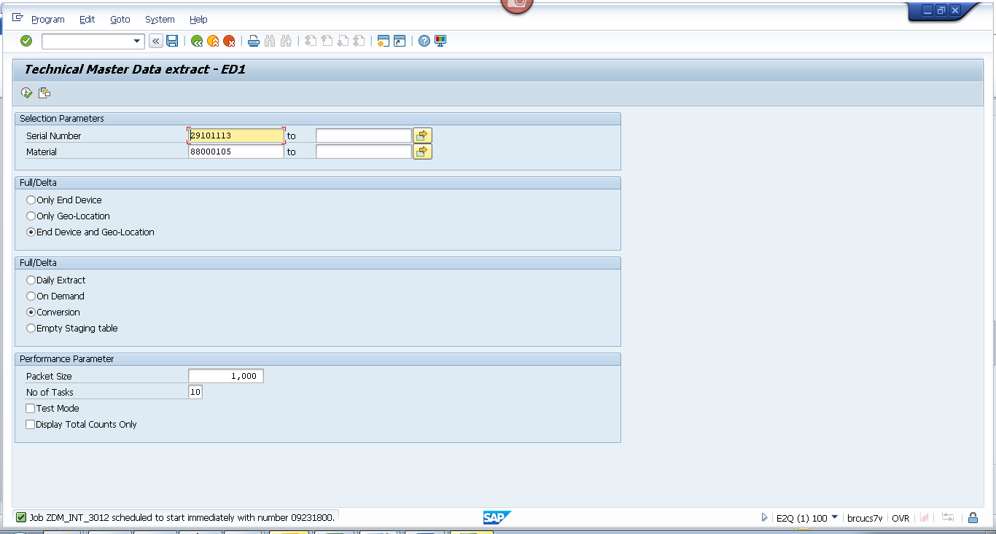
Contract 2
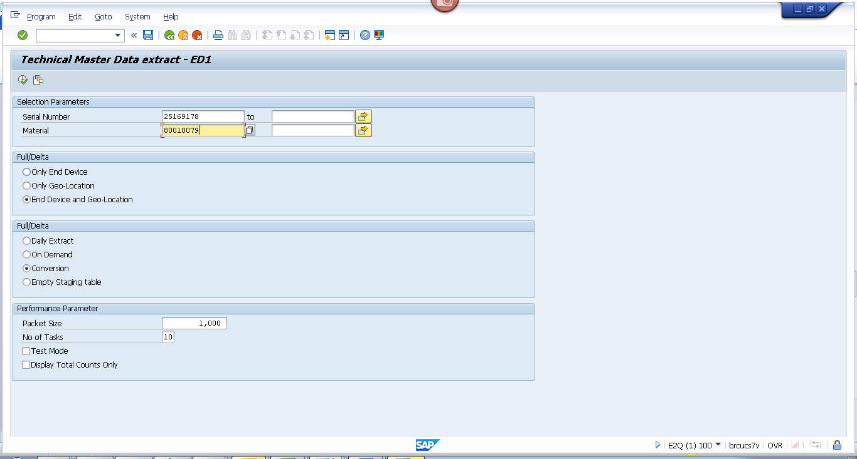
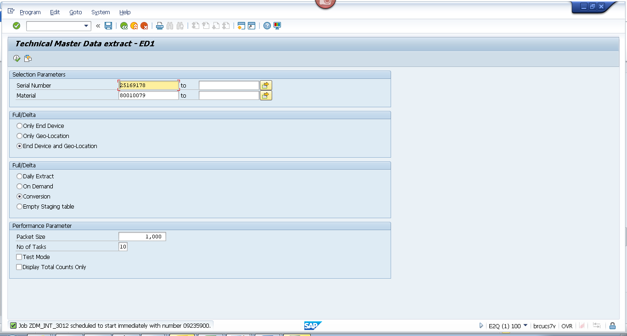

Obj tracking
Contract 1
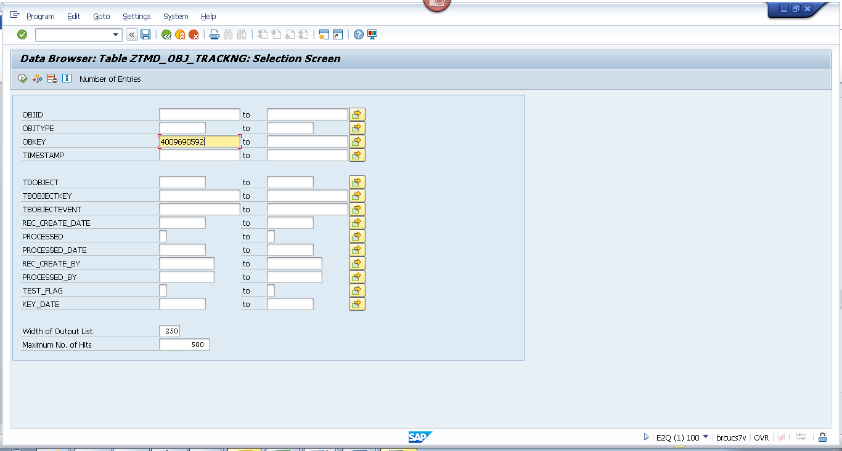
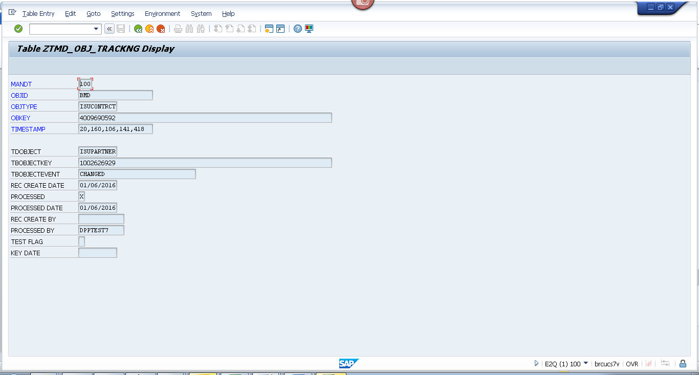Contract 2
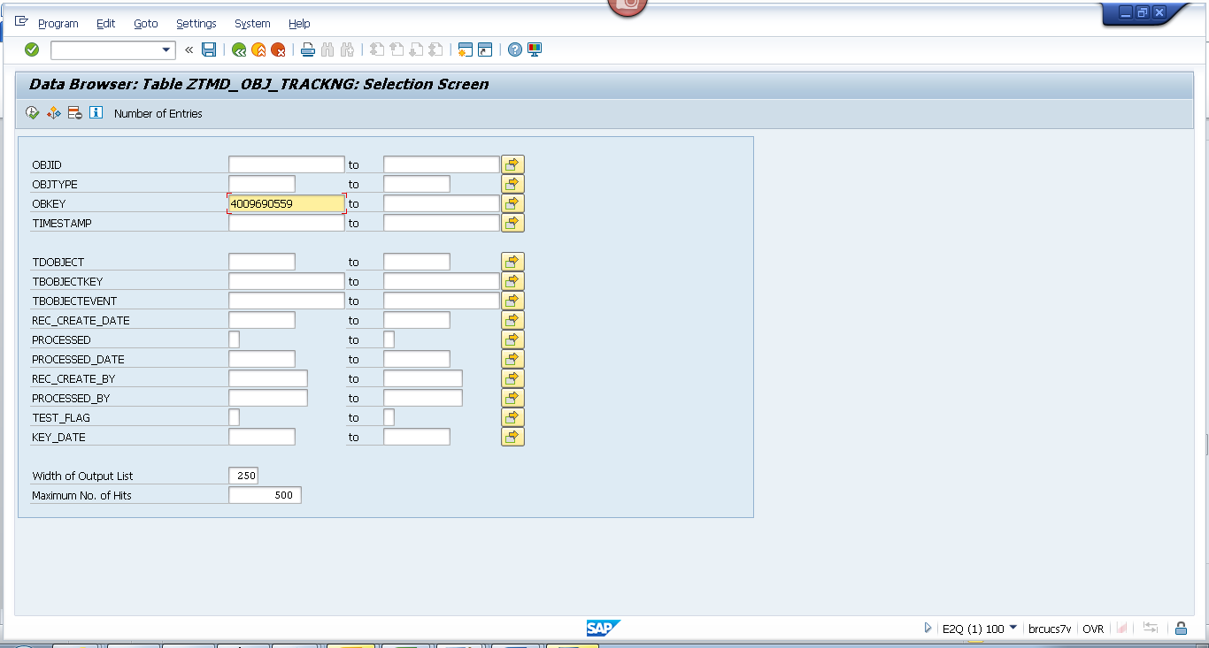
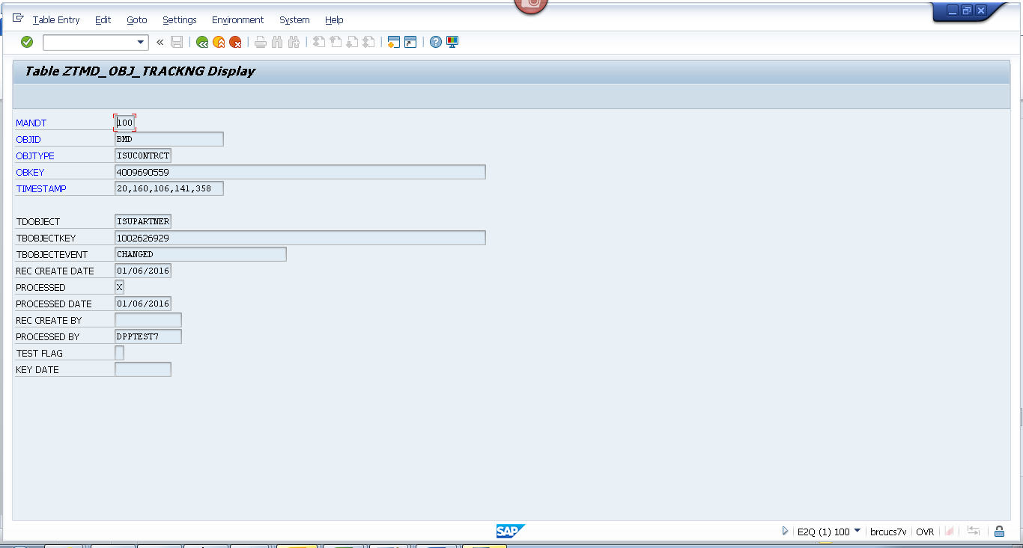

Spool
Contract 1
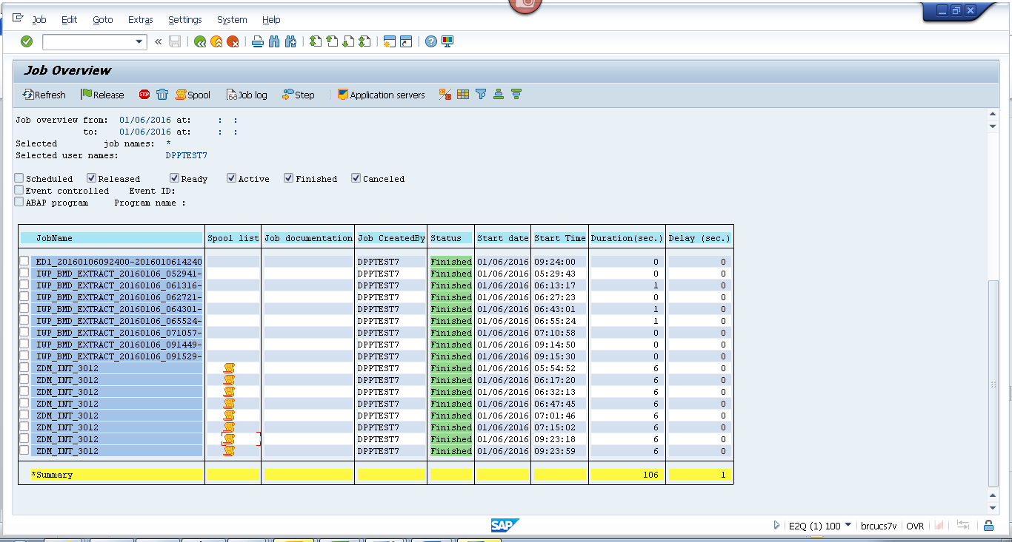
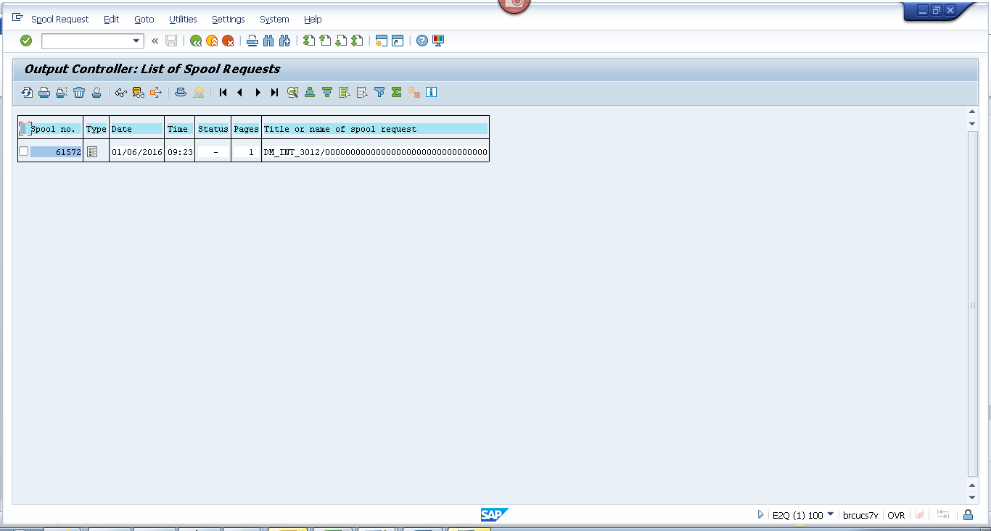
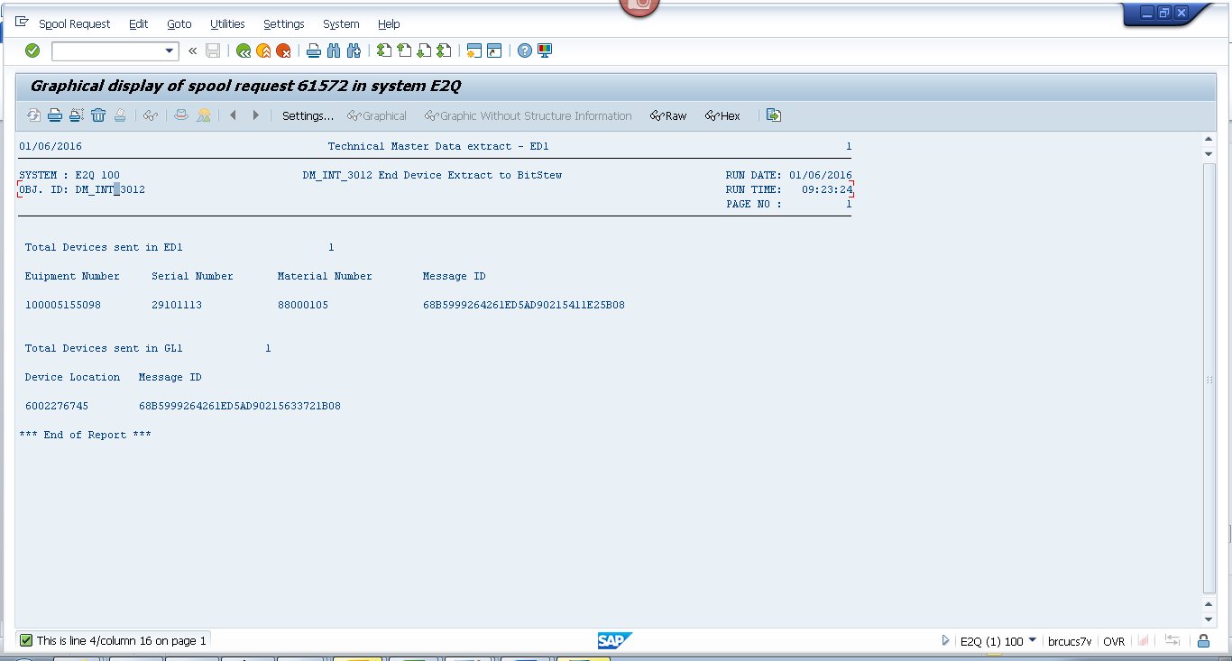
Contract 2
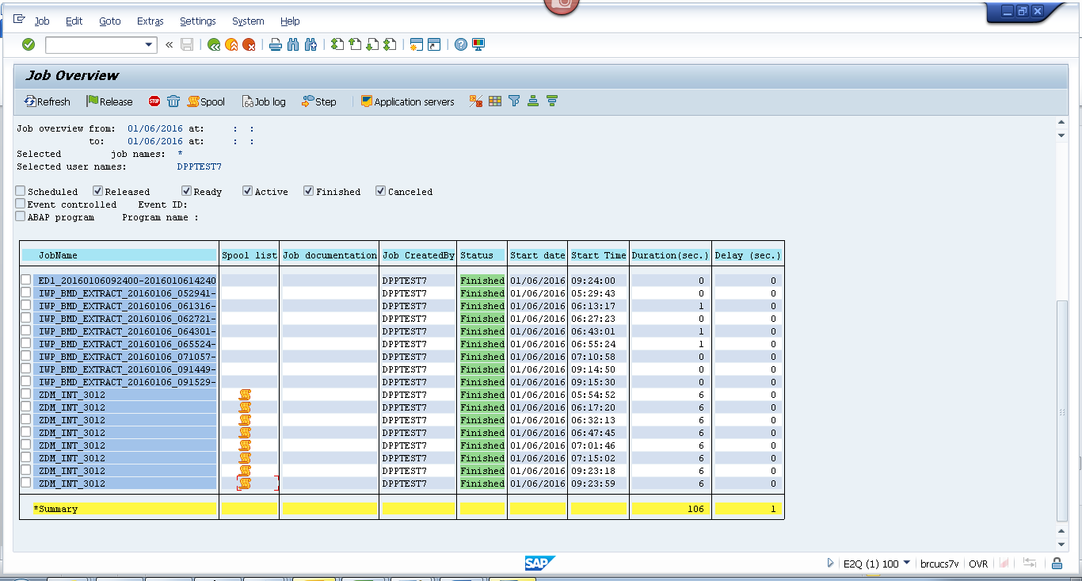
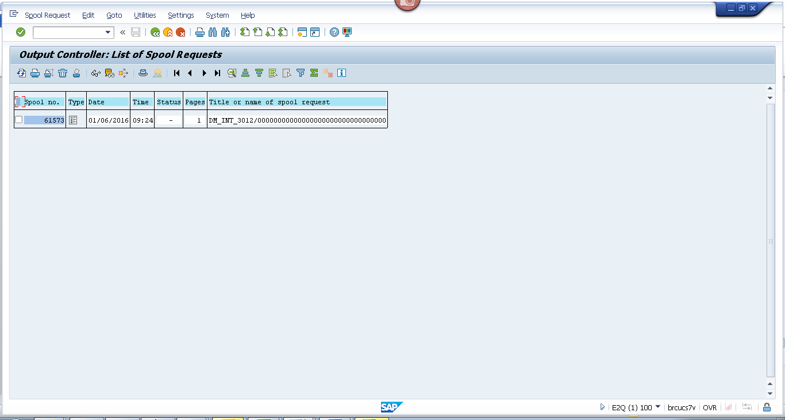
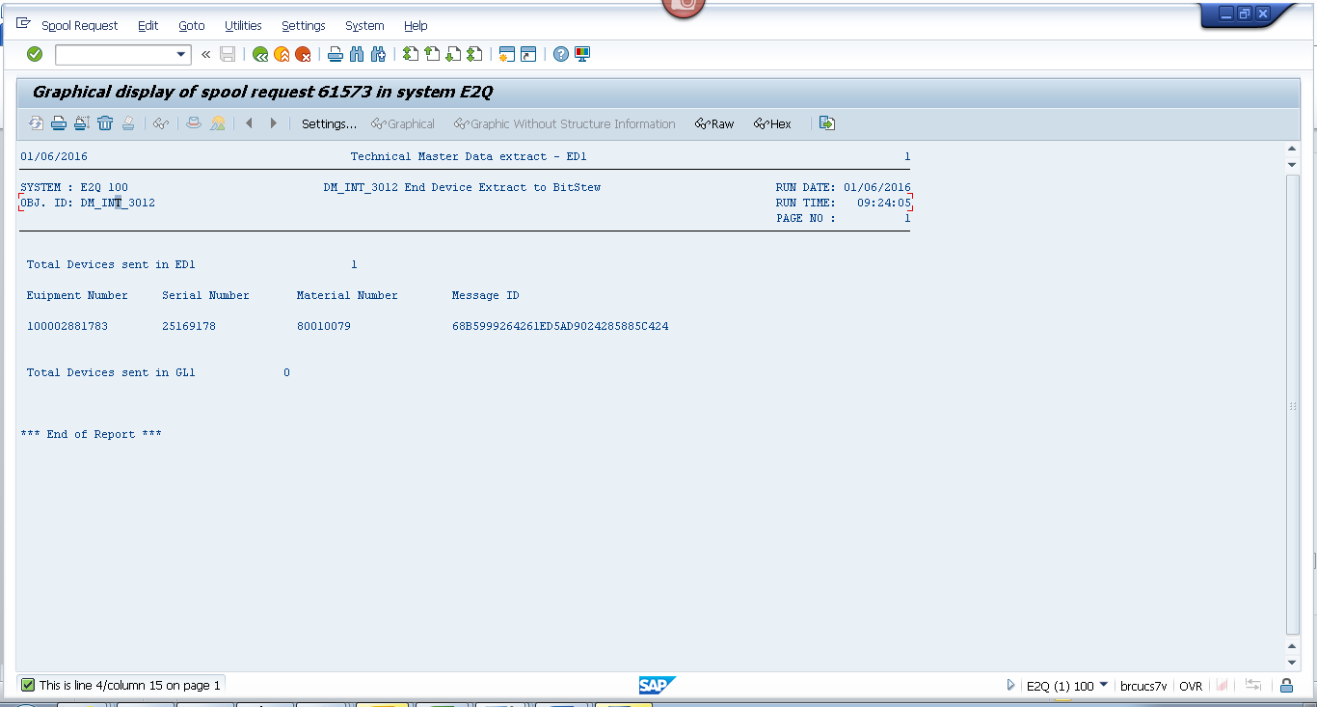

Payload

Geo loc
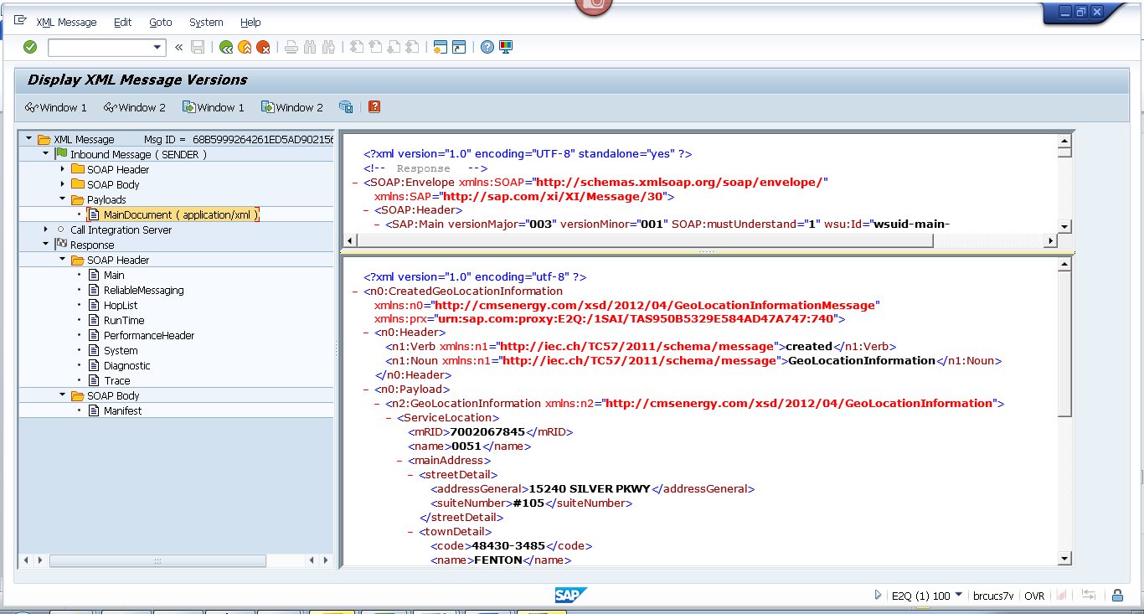
<?xml version="1.0" encoding="utf-8" ?>
- <n0:CreatedGeoLocationInformation xmlns:n0="http://cmsenergy.com/xsd/2012/04/GeoLocationInformationMessage" xmlns:prx="urn:sap.com:proxy:E2Q:/1SAI/TAS950B5329E584AD47A747:740">
- <n0:Header>
<n1:Verb xmlns:n1="http://iec.ch/TC57/2011/schema/message">created</n1:Verb>
<n1:Noun xmlns:n1="http://iec.ch/TC57/2011/schema/message">GeoLocationInformation</n1:Noun>
</n0:Header>
- <n0:Payload>
- <n2:GeoLocationInformation xmlns:n2="http://cmsenergy.com/xsd/2012/04/GeoLocationInformation">
- <ServiceLocation>
<mRID>7002067845</mRID>
<name>0051</name>
- <mainAddress>
- <streetDetail>
<addressGeneral>15240 SILVER PKWY</addressGeneral>
<suiteNumber>#105</suiteNumber>
</streetDetail>
- <townDetail>
<code>48430-3485</code>
<name>FENTON</name>
<stateOrProvince>MI</stateOrProvince>
</townDetail>
</mainAddress>
- <UsagePoints>
<mRID>6002276745</mRID>
<name>OUT RIGHT</name>
- <EndDevices>
<mRID>CA-25-05562742-0144</mRID>
<type>T</type>
</EndDevices>
- <PositionPoint>
<xPosition>-86.276745</xPosition>
<yPosition>43.276745</yPosition>
</PositionPoint>
</UsagePoints>
</ServiceLocation>
</n2:GeoLocationInformation>
</n0:Payload>
</n0:CreatedGeoLocationInformation>

End Device
Contract 1
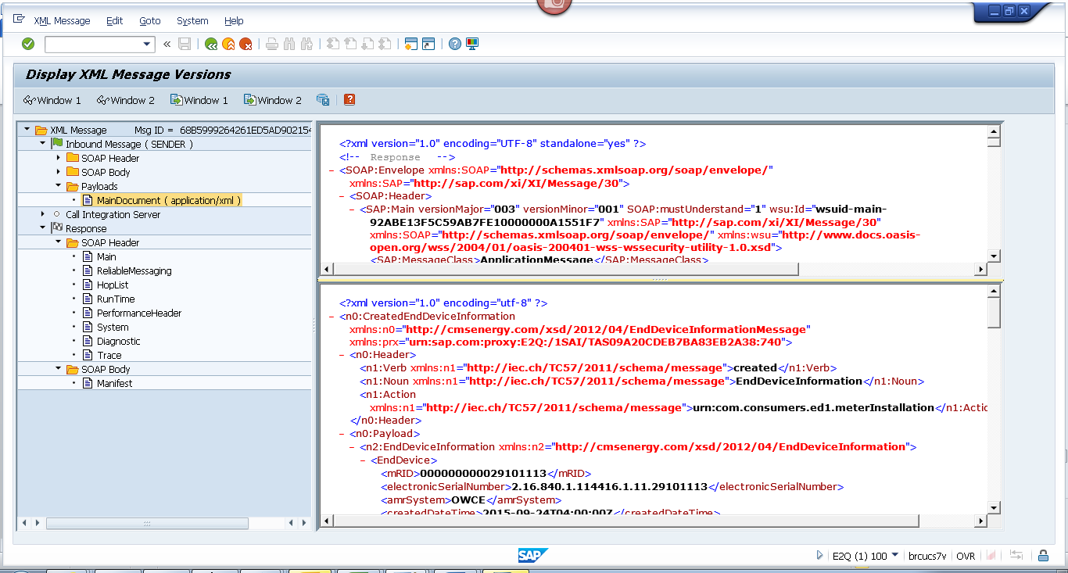
<?xml version="1.0" encoding="utf-8" ?>
- <n0:CreatedEndDeviceInformation xmlns:n0="http://cmsenergy.com/xsd/2012/04/EndDeviceInformationMessage" xmlns:prx="urn:sap.com:proxy:E2Q:/1SAI/TAS09A20CDEB7BA83EB2A38:740">
- <n0:Header>
<n1:Verb xmlns:n1="http://iec.ch/TC57/2011/schema/message">created</n1:Verb>
<n1:Noun xmlns:n1="http://iec.ch/TC57/2011/schema/message">EndDeviceInformation</n1:Noun>
<n1:Action xmlns:n1="http://iec.ch/TC57/2011/schema/message">urn:com.consumers.ed1.meterInstallation</n1:Action>
</n0:Header>
- <n0:Payload>
- <n2:EndDeviceInformation xmlns:n2="http://cmsenergy.com/xsd/2012/04/EndDeviceInformation">
- <EndDevice>
<mRID>000000000029101113</mRID>
<electronicSerialNumber>2.16.840.1.114416.1.11.29101113</electronicSerialNumber>
<amrSystem>OWCE</amrSystem>
<createdDateTime>2015-09-24T04:00:00Z</createdDateTime>
<installCode>5001966408</installCode>
<serialNumber>000000000088000105</serialNumber>
<type>01</type>
- <Customer>
- <CustomerAccounts>
- <CustomerBillingInfos>
<mRID>RES</mRID>
<type>A_200</type>
<startDate>1900-01-01T05:00:00Z</startDate>
<endDate>2008-10-30T04:00:00Z</endDate>
<readRoute>090501</readRoute>
<readCycle>05</readCycle>
</CustomerBillingInfos>
- <CustomerBillingInfos>
<mRID>RES</mRID>
<type>RS_1000</type>
<startDate>2008-10-31T04:00:00Z</startDate>
<endDate>2010-04-13T04:00:00Z</endDate>
<readRoute>090501</readRoute>
<readCycle>05</readCycle>
</CustomerBillingInfos>
- <CustomerBillingInfos>
<mRID>RES</mRID>
<type>RS_1000</type>
<startDate>2010-04-14T04:00:00Z</startDate>
<endDate>9999-12-31T05:00:00Z</endDate>
<readRoute>090510</readRoute>
<readCycle>05</readCycle>
</CustomerBillingInfos>
</CustomerAccounts>
</Customer>
- <EndDeviceFunction>
<mRID>000000100005155098</mRID>
<name>ESM 1PH 3W 200A 240V 2S SS RS/RT ERT</name>
<programID>1NFRSRT001</programID>
</EndDeviceFunction>
- <UsagePoint>
<mRID>6002276745</mRID>
<name>OUT RIGHT</name>
<phaseCode>A</phaseCode>
<readCycle>05</readCycle>
<readRoute>090510</readRoute>
- <Installation>
<mRID>5001966408</mRID>
</Installation>
- <MeterServiceWorks>
<type>MIV</type>
</MeterServiceWorks>
- <ServiceLocation>
<mRID>7002067845</mRID>
<name>0051</name>
- <mainAddress>
- <streetDetail>
<addressGeneral>15240 SILVER PKWY</addressGeneral>
<suiteNumber>#105</suiteNumber>
</streetDetail>
- <townDetail>
<code>48430-3485</code>
<name>FENTON</name>
<stateOrProvince>MI</stateOrProvince>
</townDetail>
</mainAddress>
</ServiceLocation>
</UsagePoint>
- <information>
<description>1002</description>
<title>AMCG</title>
</information>
- <status>
<reason>System Status</reason>
<value>Installed</value>
</status>
- <status>
<reason>User Status</reason>
<value>No Special test Available</value>
</status>
- <status>
<dateTime>2015-08-04T04:00:00Z</dateTime>
<reason>Cutover Date</reason>
</status>
- <status>
<dateTime>2015-08-01T04:00:00Z</dateTime>
<value>Install Date</value>
</status>
- <status>
<reason>Certification Year</reason>
<value>2015</value>
</status>
- <status>
<reason>Certification Status</reason>
<value>No restriction</value>
</status>
</EndDevice>
</n2:EndDeviceInformation>
</n0:Payload>
</n0:CreatedEndDeviceInformation>
Contract 2
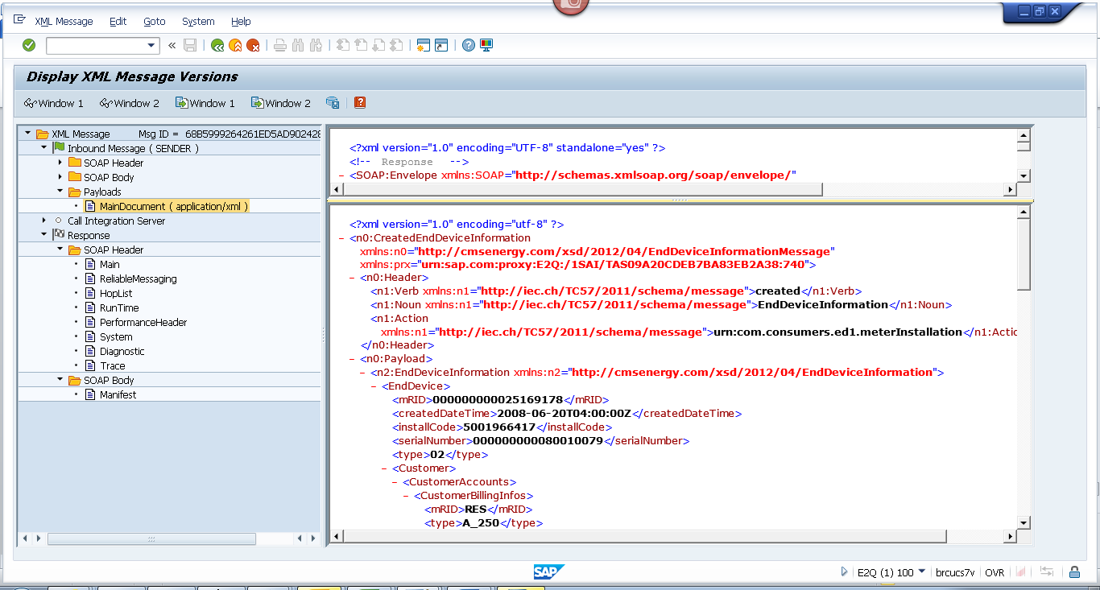
<?xml version="1.0" encoding="utf-8" ?>
- <n0:CreatedEndDeviceInformation xmlns:n0="http://cmsenergy.com/xsd/2012/04/EndDeviceInformationMessage" xmlns:prx="urn:sap.com:proxy:E2Q:/1SAI/TAS09A20CDEB7BA83EB2A38:740">
- <n0:Header>
<n1:Verb xmlns:n1="http://iec.ch/TC57/2011/schema/message">created</n1:Verb>
<n1:Noun xmlns:n1="http://iec.ch/TC57/2011/schema/message">EndDeviceInformation</n1:Noun>
<n1:Action xmlns:n1="http://iec.ch/TC57/2011/schema/message">urn:com.consumers.ed1.meterInstallation</n1:Action>
</n0:Header>
- <n0:Payload>
- <n2:EndDeviceInformation xmlns:n2="http://cmsenergy.com/xsd/2012/04/EndDeviceInformation">
- <EndDevice>
<mRID>000000000025169178</mRID>
<createdDateTime>2008-06-20T04:00:00Z</createdDateTime>
<installCode>5001966417</installCode>
<serialNumber>000000000080010079</serialNumber>
<type>02</type>
- <Customer>
+ <CustomerAccounts>

</Customer>
- <EndDeviceFunction>
<mRID>000000100002881783</mRID>
<name>MTR G 175/250 RMTC 1/8" Orifice</name>
</EndDeviceFunction>
- <UsagePoint>
<mRID>6002276760</mRID>
<name>OUT LEFT</name>
<readCycle>05</readCycle>
<readRoute>090510</readRoute>
- <Installation>
<mRID>5001966417</mRID>
</Installation>
- <MeterServiceWorks>
<type>OMAR</type>
</MeterServiceWorks>
- <ServiceLocation>
<mRID>7002067845</mRID>
<name>0051</name>
- <mainAddress>
- <streetDetail>
<addressGeneral>15240 SILVER PKWY</addressGeneral>
<suiteNumber>#105</suiteNumber>
</streetDetail>
- <townDetail>
<code>48430-3485</code>
<name>FENTON</name>
<stateOrProvince>MI</stateOrProvince>
</townDetail>
</mainAddress>
</ServiceLocation>
</UsagePoint>
- <information>
<description>0000</description>
<title>AMCG</title>
</information>
- <status>
<reason>System Status</reason>
<value>Installed</value>
</status>
- <status>
<reason>User Status</reason>
<value>No Special test Available</value>
</status>
- <status>
<dateTime>2002-05-01T04:00:00Z</dateTime>
<value>Install Date</value>
</status>
- <status>
<reason>Certification Year</reason>
<value>2002</value>
</status>
- <status>
<reason>Certification Status</reason>
<value>No restriction</value>
</status>
</EndDevice>
</n2:EndDeviceInformation>
</n0:Payload>
</n0:CreatedEndDeviceInformation>

